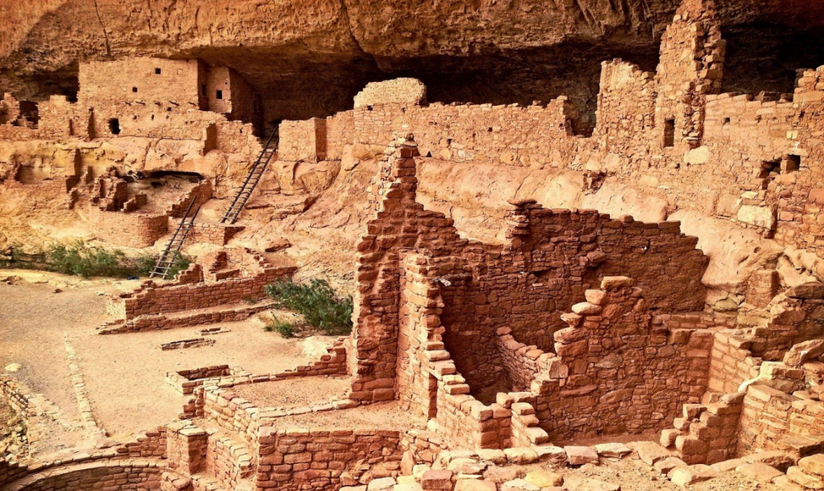

Design Document

Project 3 – Explorers Southwest

Alex Feetham | Web Design Studio | 09/03/2020